Assessment journal - Brennan Giles

<https://casoilresource.lawr.ucdavis.edu/gmap/>

Week 8

**Wind Erodibility Group:** *6*

**T Erosion Factor:** *5*

This soil is not very vulnerable to erosion, This is probably because the soil aggregates and sticks to eachother very well which helps it hold against erosion. I suspect that soils with high clay content tend to be resistant to erosion just like my soil here. This resistance to erosion could also be a factor as to why the landscape can be very hilly where I lived despite the large amounts of rain we get – it doesn’t get worn down very fast.

Week 7

The dominant use for my soil series are production of berries, row crops, orchard crops, nursery stock, grain, seed crops, hay, and pasture. It is also excellent for growing pleasure plants such as grass, scenic trees, and bushes. Private gardens commonly use this soil to great success.

It makes perfect sense given the soil properties known about this soil as it is extremely fertile, holds water very well, and has excellent structure/ aggregation. This kind of soil is what made Oregon famous for being an excellent place for growing crops. 

Interestingly, it has very limited to poor bioaccumulation potential for “large animal disposal” meaning that it isn’t very good at absorbing large amounts of organic matter. I thought since it was so fertile it would be able to absorb OM easily however it is perhaps “overly saturated” with OM? It also completely lacks engineering items such as Gravel or sand. It makes for poor septic and sewage management because it absorbs the sewage rather than transports it. It does however make for decent paths, trails, playgrounds, and camping areas.

From my own experiences there, it makes perfect sense. This soil is very soft and unless compacted from decades of hiking makes for a tough soil to traverse on. I imagine it is difficult to build on it without deep enough foundations, and I certainly wouldn’t try to build anything higher than 6 stories on it. I am still curious about what makes it a “very poor” soil for handling large animal burials, perhaps you would know?

week 6

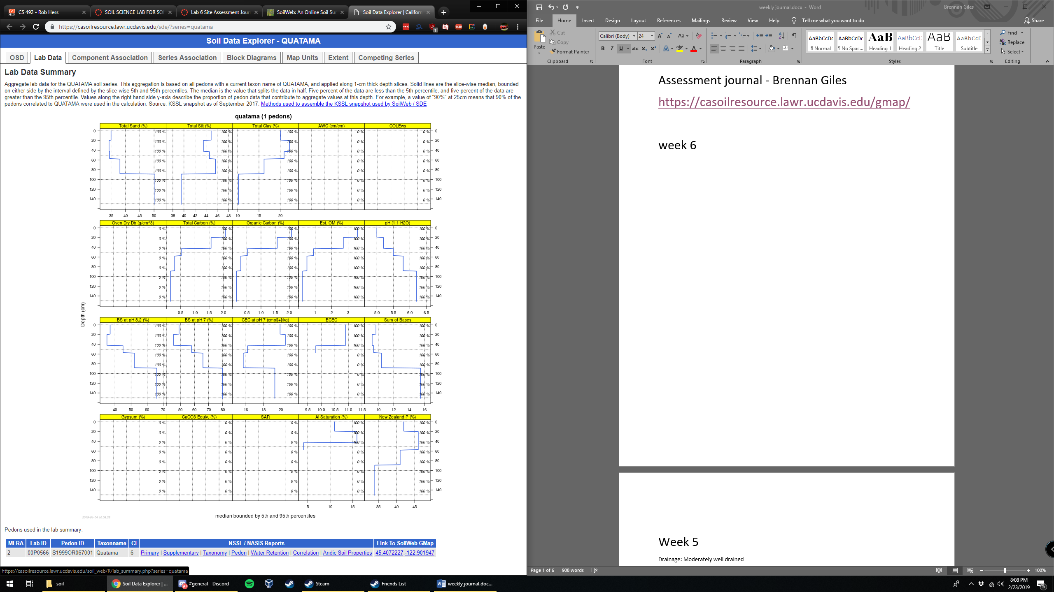

Moderately

For CEC I see that there is an average of about 12.5 cmol/kg. This makes sense; sandy soils tend to have about 3 cmol/kg while clay soils or soils with significant OM tend to have greater than 20. Since Quatoma Loam is right in between those two extremes 10 seems appropriate. For average PH it is about 5.9. Carbonate levels are less than 1% which is average. The SAR is non sodic and has a value of about 6. LEP is about 2– shrink well is not too extreme however definitely does occur to a minor extent.

Based on the above and some research I found that Alfisols tend to have equal parts 2:1 and 1:1 colloids. If I were to guess what kind of colloid is found Inside I would say Vermiculite because it has a lot of organic material, holds a lot of nutrients, and has shrink swell patterns. I choose from the colloids listed in the lectures and of these I felt Vermiculite fit the bill the best – especially because it is described as “high in Organic Matter”. Often growing up I remember how the muds would turn to expanded marshes behind the house, but dry up and shrink when it eventually got hot.

Week 5

Drainage: Moderately well drained

Water holding capacity: N/A, however plant available water is 22.97 cm

Ksat: Moderately high

Permeability: no flooding or ponding, drains well with good ksat. Can high saturation January through March

Due to loam/ sandy loam nature, infiltration rates and hydraulic conductivity are moderately high. Bulk density and porosity correspond with the sandy loam texture and both allow for this excellent drainage. Keep in mind that there is just enough clay (about 11 %) to hold water long enough for plants to thrive. Overall this makes sense, and especially in a place like Oregon where it rains often it is a good thing the soil handles water so adeptly.

\

Week 4

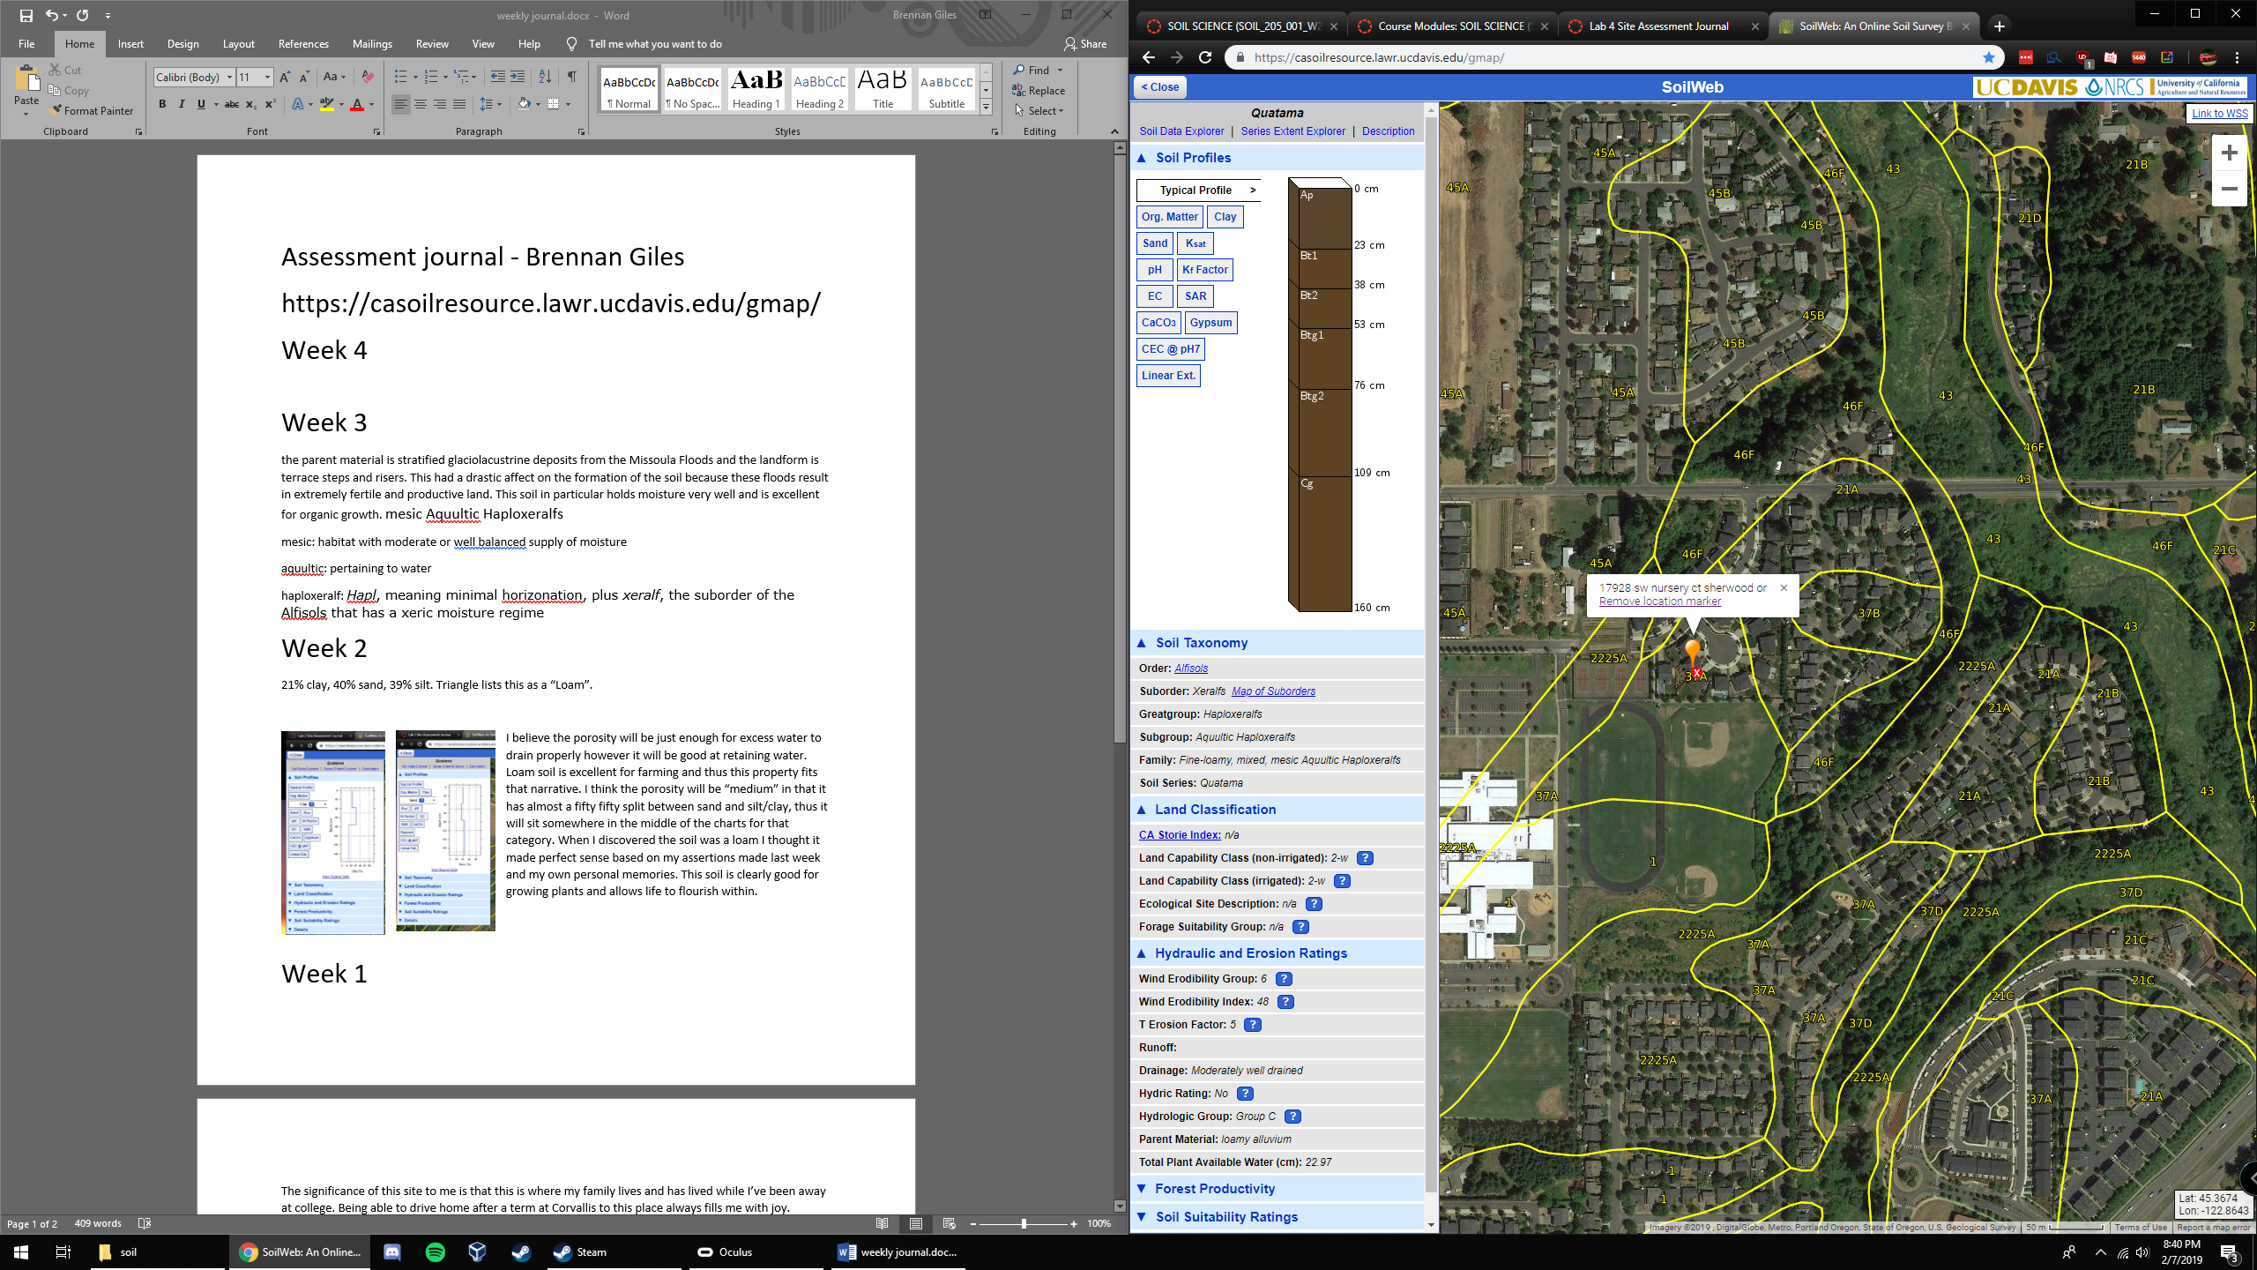Ap – brown loam, moist, moderately acidic with some organic material.

Bt1 – pale brown loam, moist, slightly sticky, moderately acidic, some fine roots present.

Bt2- pale brown clay loam mosit, hard and firm with fine roots and moderately acidic.

Btg1 – pale brown clay loam moist. Hard, firm, a little sticky with fine roots. Some oxidized iron and moderately acidic.

Btg2 – pale brown loam that is moist, slightly sticky, with iron depletions on surfaces along pores. Moderately acidic but as we go deeper it looks like it is getting more basic (by a small amount, it is still acidic)

Cg – yellowish brown loam that is moist, hard, firm, with iron depletions on surfaces along pores and masses of oxidized iron. Moderately acidic.

**Sherwood, Oregon gets 41 inches of rain, on average, per year.** The US average is 39 inches of rain per year.

**Sherwood averages 1 inches of snow per year.** The US average is 26 inches of snow per year.

**On average, there are 142 sunny days per year in Sherwood.** The US average is 205 sunny days.

**Summer High:** the July high is around 80 degrees  
**Winter Low:** the January low is 35

on surfaces along pores and masses of oxidized iron. Moderately acidic.

I couldn’t find any official documents on Sherwood Vegetation, however I know from memory that Pine trees, blackberries, grass, coniferous trees, rosemary, shrubs and vines are all very common. So are poison oak and lily pads.

Climate: the climate is very wet with very pleasant, sunny days during growing seasons making this area very fertile. As a result the soil profile is extremely fertile with predominately loam and clay-loam textures.

Organisms: there is a huge amount of worms crawling around in the soil and they contribute significantly towards the recycling of organic material within the soil.

Relief: the area features lots of valleys and hills which can result in certain areas being more fertile than others. Sherwood is in a valley so it gets most of those benefits.

Parent Material: the parent material for this soil is loamy alluvium.

Time: the soil in Sherwood is moderately developed, and for the most part has been farmed responsibly since settlers came in after the Oregon Trail. Horizons here are not substantially different from each other but have their unique qualities.

Week 3

the parent material is stratified glaciolacustrine deposits from the Missoula Floods and the landform is terrace steps and risers. This had a drastic affect on the formation of the soil because these floods result in extremely fertile and productive land. This soil in particular holds moisture very well and is excellent for organic growth. mesic Aquultic Haploxeralfs

mesic: habitat with moderate or well balanced supply of moisture

aquultic: pertaining to water

haploxeralf: *Hapl*, meaning minimal horizonation, plus *xeralf*, the suborder of the Alfisols that has a xeric moisture regime

Week 2

21% clay, 40% sand, 39% silt. Triangle lists this as a “Loam”.

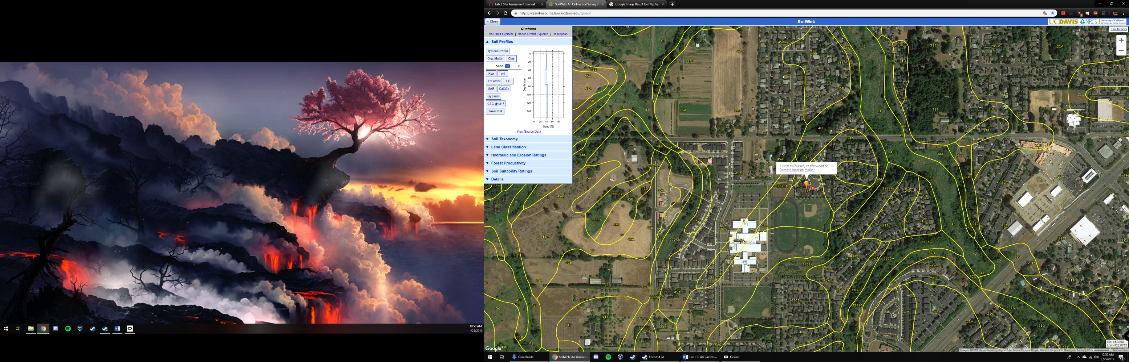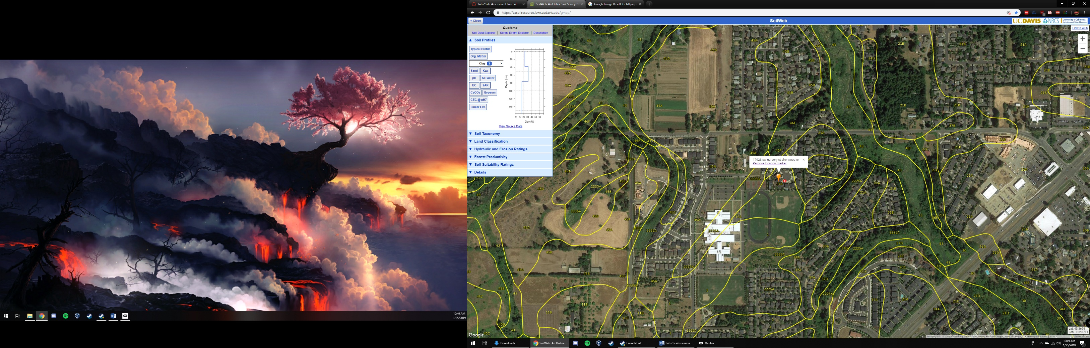I believe the porosity will be just enough for excess water to drain properly however it will be good at retaining water. Loam soil is excellent for farming and thus this property fits that narrative. I think the porosity will be “medium” in that it has almost a fifty fifty split between sand and silt/clay, thus it will sit somewhere in the middle of the charts for that category. When I discovered the soil was a loam I thought it made perfect sense based on my assertions made last week and my own personal memories. This soil is clearly good for growing plants and allows life to flourish within.

Week 1

The significance of this site to me is that this is where my family lives and has lived while I’ve been away at college. Being able to drive home after a term at Corvallis to this place always fills me with joy.

What I remember about the soil is that it is very fertile with a lot of organic matter. This may not make sense but it is some of the “healthiest” soil I know of. It is dark brown and almost entirely soil with only a sparse amount of small rocks inside.

The dominant soil series is the “Quatama Series”.

The typical pedon structure is “Quatama loam, cultivated”. At the top it is loamy, brown, moist with moderate fine and very fine subangular blocky structure. It is moderately acid and tends to have fine roots embedded within it. I’ve never tasted the soil outside my house so I didn’t know it was acidic, but other than that I think I had it spot on from memory. For some context, this area was historically extremely fertile and used as a farming location in the past.

